Install git
winget install --id Git.Git -e --source winget

To find help
git --help
or go to https://git-scm.com/docs/git-config
go into the directory in cmd
cd git
go back dir
cd ..
make directory
mkdir git

initialising an empty folder /repos as a SCM
git init
https://www.youtube.com/watch?v=8JJ101D3knE

lets say we create a file and write some content into the file
echo hello > file1.txt

to edit in notepad
start notepad index.html

to track/check status of the file
git status
then we will realise all files not added to branch
To let GIT track them
Use add command
Git add file1.txt
Git add file2.txt
Can also type add file1.txt file2.txt
Can also type this for all staging files
git add .

to remove what added
git reset

To permanently store in git repository
Git commit –m “….your message..”
Once done they will tell you how many lines inserted and files committed

Make some change like type “bug fixer” in file 1
Then type git add file1.txt

If file2 is not needed as the system is removed and we don’t need the code in the repository
Git rm file2.txt
For files not added via the git add command but manually, it cannot be remove by above command until git add file3.txt is done and git commit

To check for files in
git ls-files

To rename files with cmd, it go into staging. then you need to add into repository after it is in staging
rename file1.txt file2.txt

To create a sub branch from the master branch to do a subtract function and multiply
git branch subtract
git branch multiply
to see all branches type
git branch
IF WE SEE THE *AND GREEN, IT MEANS MASTER IS CHECKED OUT
just to see and review OTHER BRANCH
git checkout subtract

to merge branch forward merge approach
switch to master branch then merge with the sub branch
git merge multiply
if have issue
do a git merge --abort
“write ur merge message
Press esc
Type :wq at the end

To delete sub branch that we have completely merged with main branch
Git branch –d multiply

To establish connection with github from git then push master to git hub.
To see your url, click on the code. To see which branch check below
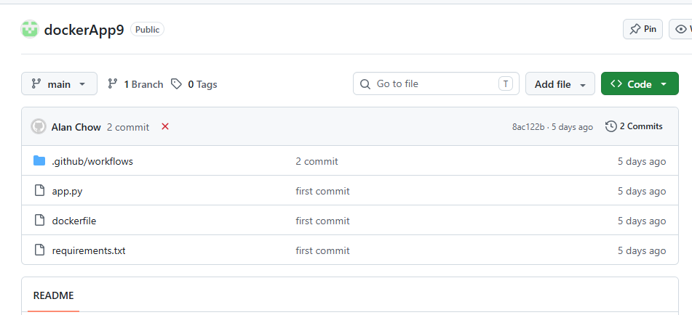
git remote add origin https://github.com/alanchow85/repositoryIt204F.git
git remote add origin https://github.com/alanchow85/dockerApp9.git

git push -u origin main
git push -u origin master

where to find the github hyperlink?
Click on the < > code green button
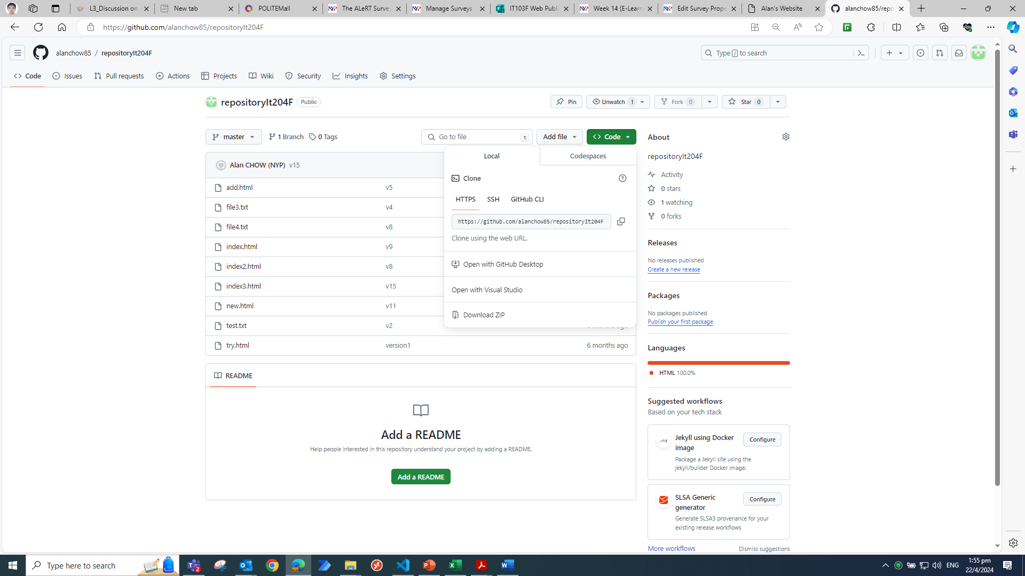

If conflict use force push
git push --force origin master

To change git location
git remote add origin https://github.com/alanchow85/repositoryIt204F.git
To clone github things
git clone https://github.com/alanchow85/newrepo.git

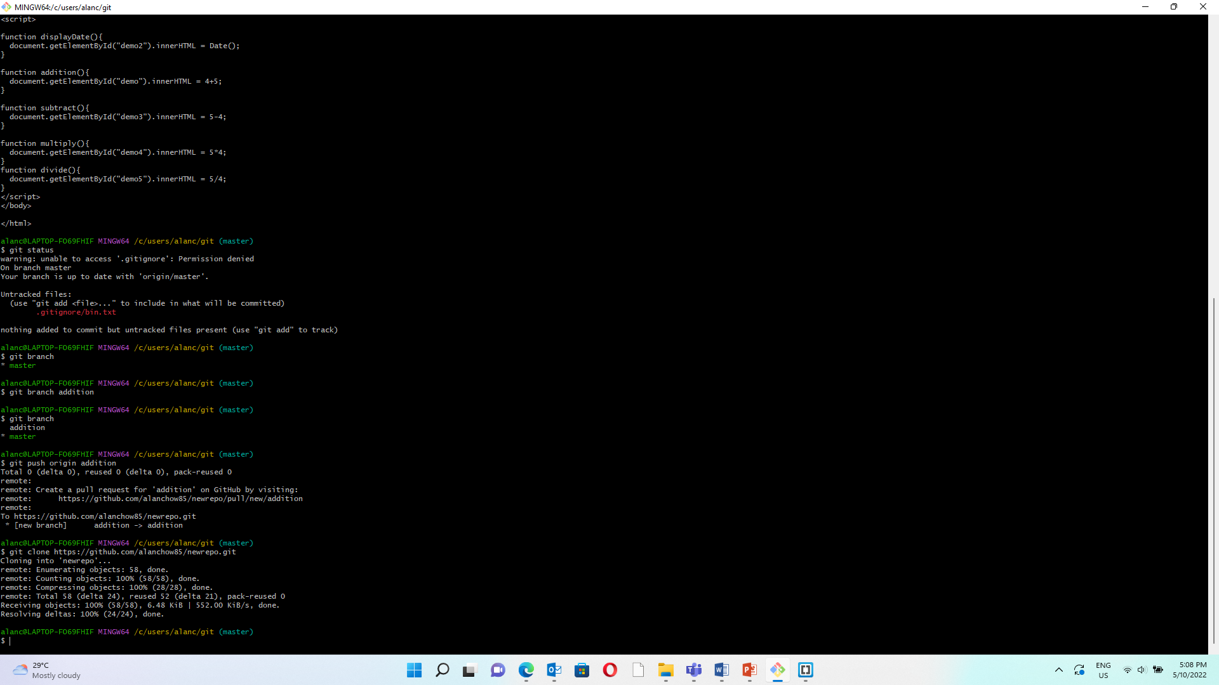

to restore to previous commit

git revert hashcode
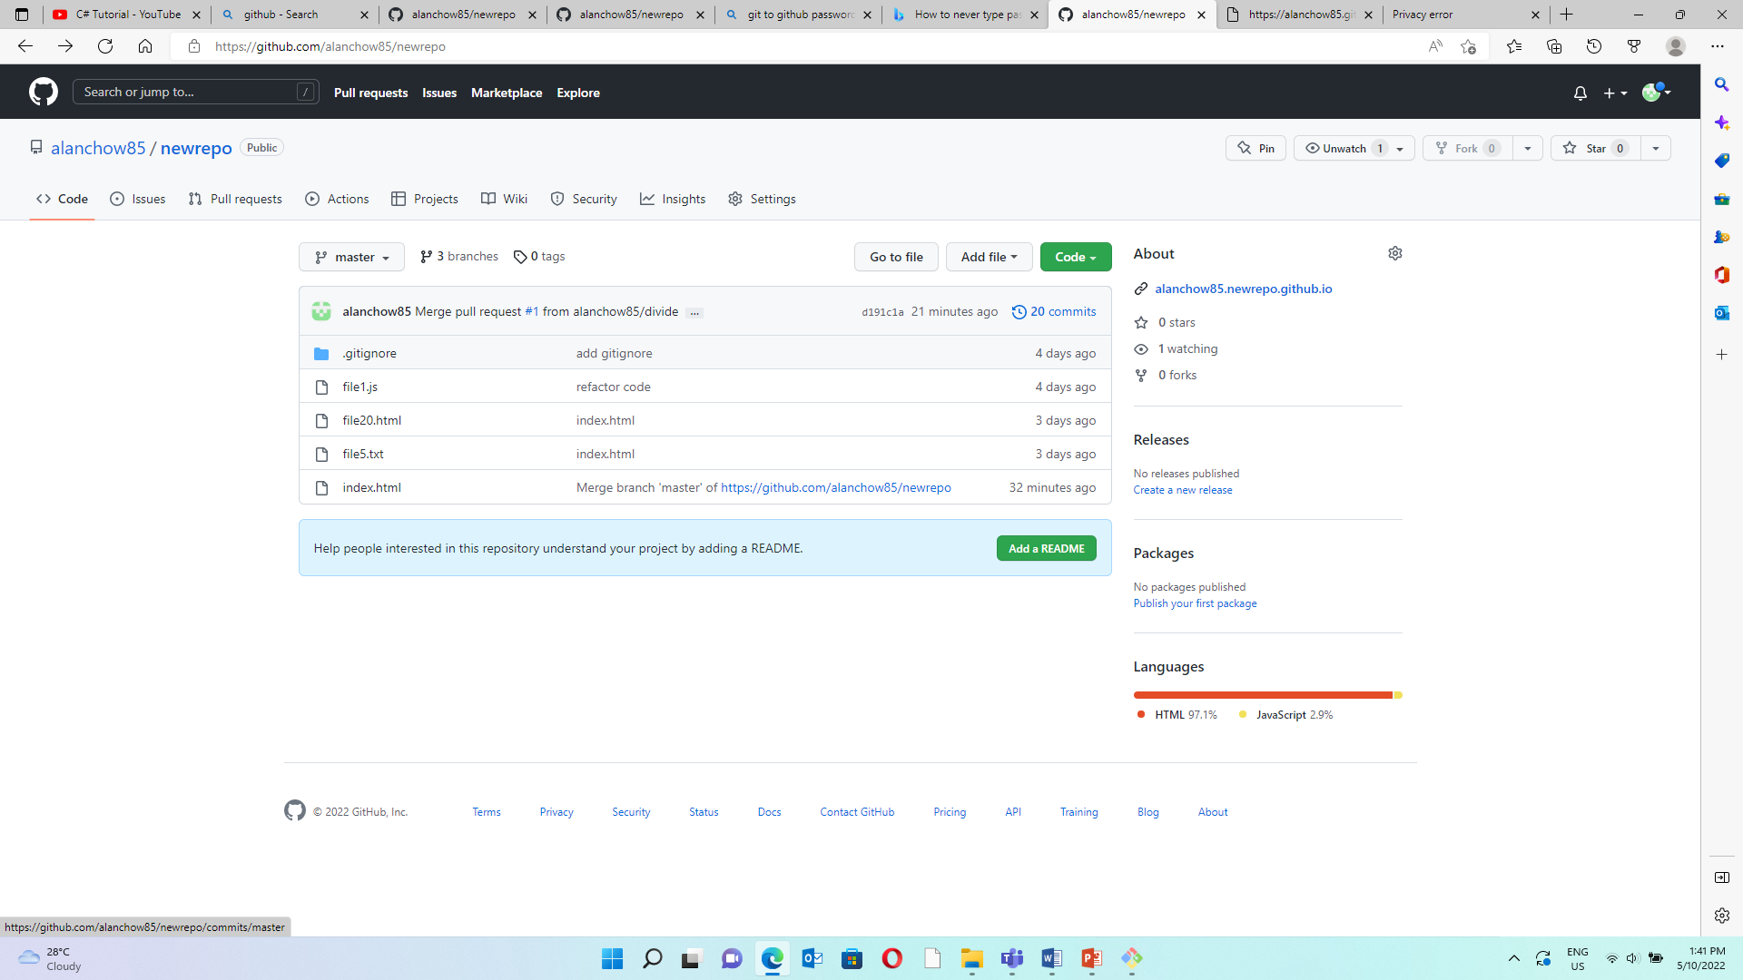
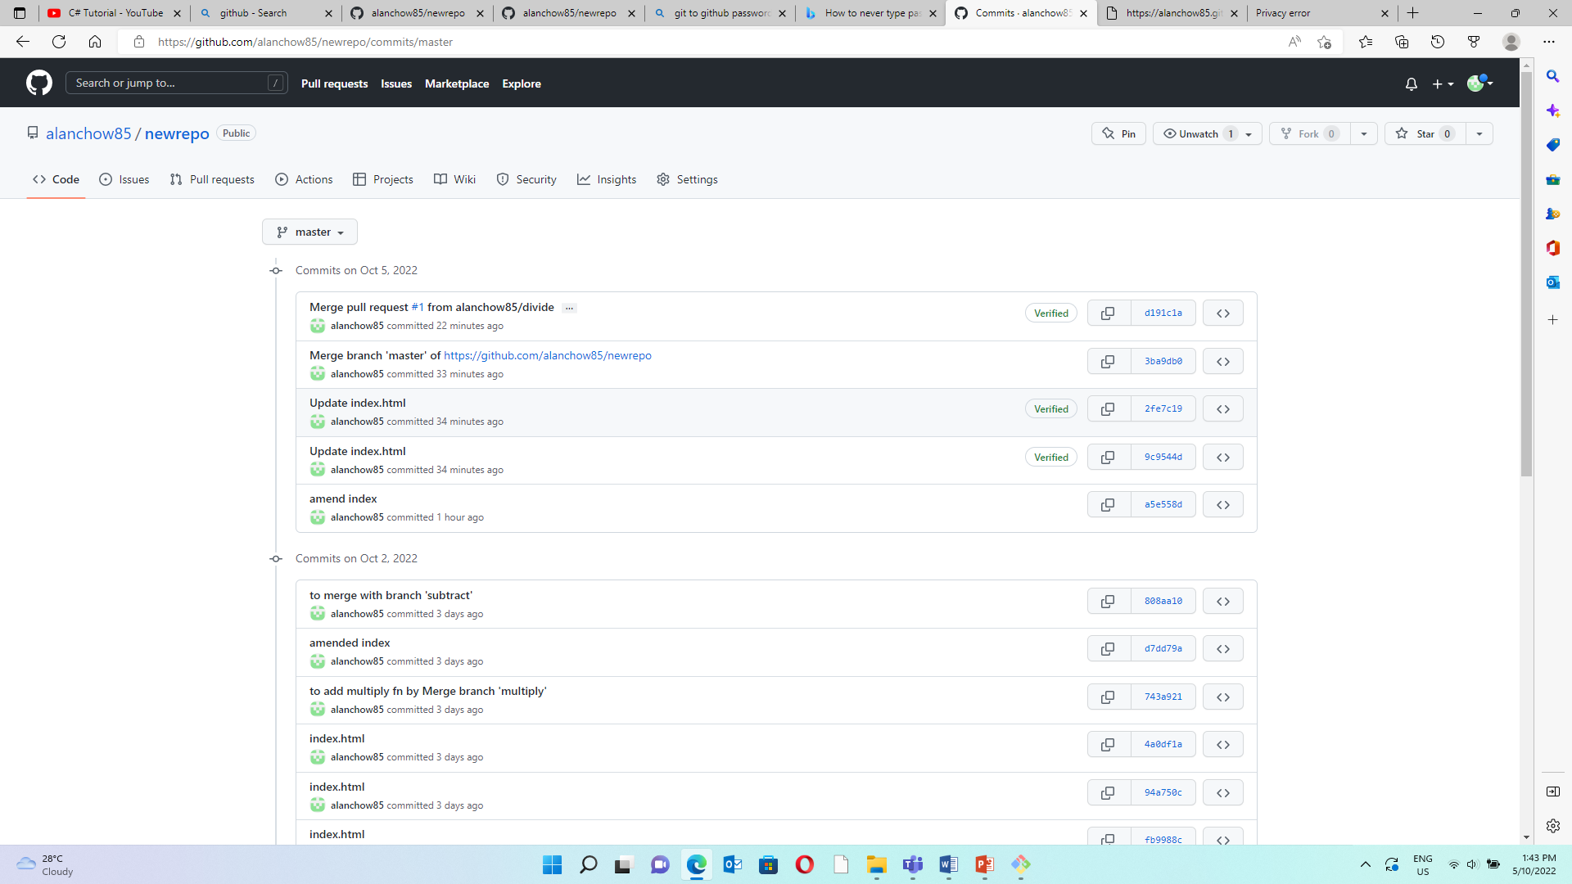

ignore files
mkdir .gitignore
Git commit –m “add gitignore”
Remove folder accidently in staging
git rm --cached -r log/

to view previous committed log
git log

to really go to the previous state
git reset “xxx the number in the git log”
git reset “385e6e9c3fd7953d2fe8501f05f7d8a1294773e9”

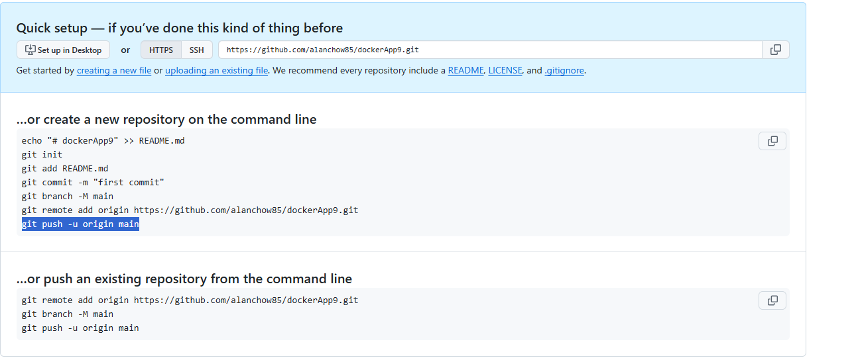

CI/CD
At the root of your project folder, do the following

Mkdir .github\workflows

Echo '' > .github\workflows\ci.yml

